Article

A SWATH-MS analysis of Myalgic Encephalomyelitis/Chronic Fatigue Syndrome peripheral blood mononuclear cell proteomes reveals mitochondrial dysfunction

**Eiren Sweetman1, Torsten Kleffmann1, Christina Edgar1, Angus Mackay1, Michel de Lange2, Rosamund Vallings3, and Warren Tate1\***

1 Department of Biochemistry, University of Otago, Dunedin 9016, New Zealand

2 Biostatistics Unit, Otago Medical School Dean’s Office, University of Otago, Dunedin 9016, New

Zealand

3 Howick Health and Medical Centre, Auckland 2014, New Zealand

**\*** Correspondence: [warren.tate@otago.ac.nz](mailto:warren.tate@otago.ac.nz)

**Abstract**

**Background:** Myalgic Encephalomyelitis/Chronic Fatigue Syndrome (ME/CFS) is a serious and complex physical illness that affects all body systems with a multiplicity of symptoms, but key hallmarks of the disease are pervasive fatigue and ‘post-exertional malaise’, exacerbation after physical and/or mental activity of the intrinsic fatigue and other symptoms that can be highly debilitating and last from days to months. Although the disease can vary widely between individuals, common symptoms also include pain, cognitive deficits, sleep dysfunction, as well as immune, neurological and autonomic symptoms. Typically, it is a very isolating illness socially, carrying a stigma because of the lack of understanding of the cause and pathophysiology.

**Methods:** To gain insight into the pathophysiology of ME/CFS, we examined the proteomes of peripheral blood mononuclear cells (PBMCs) by SWATH-MS analysis in a small well-characterised group of patients and matched controls. A principal component analysis (PCA) was used to stratify groups based on protein expression patterns and the majority of the ME/CFS patients (7/11) clearly separated from the controls and remaining ME/CFS patients within this analysis. This majority subgroup of ME/CFS patients was then also compared to the control group.

**Results:** A total of 66 proteins in the ME/CFS patients were differentially expressed (*P* < 0.01, Log10 (Fold Change) > 0.2 and < -0.2). Comparison of the PCA selected subgroup of ME/CFS patients (7/11) with controls increased the number of proteins differentially expressed to 211. Of particular relevance to the core symptoms of fatigue and post-exertional malaise experienced in ME/CFS, a proportion of the identified proteins in the ME/CFS groups were involved in mitochondrial function, oxidative phosphorylation, electron transport chain complexes, and redox regulation. A significant number were also involved in previously implicated disturbances in ME/CFS, such as the immune inflammatory response, DNA methylation, apoptosis and proteasome activation.

**Conclusions:** The results from this study support a model of deficient ATP production in ME/CFS, compensated for by upregulation of immediate pathways upstream of Complex V that would suggest an elevation of oxidative stress. This study and others have found evidence of a distinct pathology in ME/CFS that holds promise for developing diagnostic biomarkers.

**Keywords:** myalgic encephalomyelitis; chronic fatigue syndrome; diagnostic biomarker; mitochondria; oxidative phosphorylation; reactive oxygen species; oxidative stress; metabolism; inflammation and immunity.

1. Introduction

Myalgic Encephalomyelitis/Chronic Fatigue Syndrome (ME/CFS) is an illness characterized by debilitating fatigue lasting more than 6 months that is not alleviated by rest. The myriad of symptoms is exacerbated by physical or mental exertion. ME/CFS affects approximately 0.5-1% of the global population, all age groups and socioeconomic strata, but is more common in women (reports of this female bias vary, and range between a 2:1 to 6:1 female to male ratio) [1,2,3]. ME/CFS is a complex disease involving profound dysregulation of the central nervous system (CNS) and immune system, dysfunction of cellular energy metabolism and ion transport, and as well cardiovascular abnormalities [4]. The likelihood of a full recovery is poor; with as few as 6% of sufferers reported to return to their previous state of wellbeing [5,6]. Flu-like and respiratory symptoms are common, and for a large subset of sufferers, the onset of the illness is sudden and is preceded by an acute viral-like infectious period. In many patients this is linked to an Epstein Barr infection and glandular fever [4]. There is speculation the current Covid-19 pandemic might see a significance increase in the incidence of ME/CFS, as reported after the original SARS epidemic [7]. Already, a high rate of post viral fatigue has been reported, and in some patients this is likely to develop into ME/CFS.

Gradual onset of ME/CFS is also reported, with the 'symptom complex' developing over a period of several weeks or months [3]. Nevertheless, current diagnostic criteria describe ME/CFS as disabling physical and mental fatigue, usually of *acute* onset, which is significantly exacerbated by exercise and activity, and by mental or emotional exertion [3,6]. A formal medical diagnosis can only be given after a process of exclusion of other well-established fatigue illnesses, and there is a range of self-reported symptoms that fit within one of several available widely defined sets of clinical criteria for ME/CFS [2,8,9]. There are as yet no agreed diagnostic markers or definitive clinical tests, the causative agent is not well understood, and the resulting disease pathophysiology is still ill-defined [10]. Immune dysfunction, chronic viral infection and, recently, metabolic and mitochondrial dysregulation have all been implicated as possible underlying consequences of ME/CFS that sustain the illness. We have also recently proposed that chronic neuro-inflammation involving the paraventricular nucleus of the hypothalamus could be a critical factor in sustaining ME/CFS [11]. In recent years ME/CFS research has shifted its focus from attempting to identify a universal 'causative agent' for the illness, to instead ascertaining the key affected physiology and biological pathways behind the ME/CFS symptom complex. High-throughput molecular analyses including cytokine production [12], metabolomics [13-16], the microbiome [17-19], epigenetics [20-23], transcriptome [24-26] and proteome investigations [27-32] have provided substantial evidence of immune/inflammation involvement, and, significantly, suggest there are deficits in energy metabolism and mitochondrial function in ME/CFS. While there have been inconsistencies in the evidence for mitochondrial dysfunction, a growing number of research papers are supportive of this hypothesis. Previous studies from our laboratory have used a small cohort of carefully diagnosed ME/CFS patients (the Dunedin cohort) and carried out extensive molecular studies utilizing the principles of precision medicine [33] with strict statistical limits. We have identified highly significant differences between the patient and control groups [10,26].

The current research has extended these analyses by exploring the expressed proteins in peripheral blood mononuclear cells (PBMCs) from the Dunedin cohort, compared with their age- and gender- matched control subjects. It has utilized for the first time the comprehensive data independent acquisition method of SWATH-MS to identify affected biological pathways. Liquid chromatography coupled to tandem mass spectrometry (LC-MS/MS) has developed into the technology of choice for high-throughput characterization of proteins and proteomes [34], particularly in the initial discovery phase. SWATH-MS is a recently emerged LC-MS/MSALL strategy that allows systematic, unbiased detection and quantitation of detectable compounds in a sample. Individual proteins, or their patterns of expression or "biosignatures", may yet prove to be valuable biomarkers in a diagnostic assay for ME/CFS and may also prove effective in gauging disease severity, dynamic variations in symptomatology, and longitudinal alterations assessing relapse and recovery phases of the illness, or other factors like treatments [10,34]. Given that at present, in some countries and among some health practitioners, there is still controversy over whether ME/CFS is a legitimate medical condition, proteome, transcriptome, and metabolome profiles can provide valuable initial objective evidence for the legitimacy of ME/CFS as a distinct disease.

This ’discovery’ study was designed to cast a wide net to maximize the identification of as many proteins as possible in the study samples, as failure to identify them at this initial stage in the broad discovery list would preclude them from future examination for their involvement in biological pathways or their validation. The proteome analysis presented here, while further establishing the disturbance in regulation of immune and inflammatory biological pathways in ME/CFS, also provides evidence of histone methylation and proteasome activation. Most significantly, however, a large number of mitochondrial proteins were increased in expression, particularly those involved in the complexes of the electron transport chain, specifically Complex I (NADH Coenzyme Q oxidoreductase), oxidative phosphorylation (OXPHOS) (complex 5), the oxidative stress response and the TCA cycle. These changes in key proteins involved in the complexes of energy production and regulation of reactive oxygen species (ROS) form the main focus for this paper, as a novel and significant result of the analysis. The results suggest there is a deficiency in ATP production and mitochondrial function, compensated for by increased expression of proteins involved in the key ATP generating pathways. It complements a recent comprehensive study that also found increased in expression of the OXPHOS proteins, coupled with deficient ATP production by Complex V (ATP synthase) leading to their hypothesis of ME/CFS patients having a deficit in spare respiratory capacity in times of physical or other stress [27].

**2. Materials and Methods**

2.1. Peripheral blood mononuclear cell (PBMC) collection and isolation

The study had approvals from by Health and Disability Ethics Committees in New Zealand (NTY/12/06/055 and 15426). Eleven ME/CFS patients diagnosed according to the 2003 Canadian consensus criteria (CCC) [35] by an experienced ME/CFS clinician, were recruited along with age- and gender-matched controls (Table 1). All participants gave their informed signed consent to participate. The control group had no history of significant illness, injury, or fatigue related disorders. ME/CFS patients completed a detailed questionnaire, developed in-house, providing their clinical history and current health status.

**Table 1:** The ME/CFS study cohort

|  |  |  |
| --- | --- | --- |
| **Clinical Characteristics** | **ME/CFS participants** | **Control participants** |
| Number | 11 | 9 |
| Median age (years) | 43.2 | 38.0 |
| Age range (years) | 11.3-69 | 12.5-60 |
| Gender | F = 7  M = 4 | F = 6  M = 3 |
| Median BMI | 23.7 | ** |
| Nationality | NZ/European | NZ/European |
| Median illness duration (years) | 11 | N/A |
| Stage of illness* | Acute = 2  Chronic = 9 | N/A |
| Potential initial ME/CFS ‘trigger’ | Acute infection = 7  Surgery = 1  Stress = 1  Unsure = 2 | N/A |

*self-reported ** Data not collected.

Within 4 h of collection, whole blood samples were diluted 1:1 with filter-sterilized PBS, layered onto Ficoll-Paque PLUS (Sigma-Aldrich), and centrifuged at 400 x g for 40 min. The PBMC interface layer was removed and washed twice with filter-sterilized PBS. The isolated PBMCs were then mixed with RNAlater (Thermo Fisher Scientific) (1:5 ratio) for storage.

*2.2. Cell lysis and protein digestion*

Frozen pellets of isolated PBMCs were reconstituted in 200 µl of lysis buffer containing 0.2% (m/v) SDS (sodium dodecyl sulfate), 1mM EDTA (ethylenediaminetetraacetic acid), 1mM EGTA (ethylene glycol-bis(β-aminoethyl ether)-N,N,N′,N′-tetraacetic acid), 5 mM TCEP (tris(2-carboxyethyl)phosphine) in 40 mM Tris-base (tris(hydroxymethyl)aminomethane). The homogenates were sonicated for 2 min and then centrifuged at 16,000 x g and 20°C for 30 min. The supernatants were removed and diluted with 200 µl of detergent depletion buffer (8 M urea in 100 mM triethyammonium bicarbonate (TEAB)). All samples were then further processed by the filter-aided sample processing (FASP) protocol [36]. Protein was then digested on filters with sequencing grade trypsin (Promega) using a trypsin/protein ratio of 1/20. After an overnight digestion samples were boosted with an additional aliquot of trypsin and further digested for 4h. The digestion was then stopped by acidification with formic acid at a final concentration of 0.1%. One third of each sample was pooled into a single sample for peptide fractionation by off gel-isoelectric focusing (OG-IEF). The remainder of the individual samples and the pooled sample were dried using a centrifugal vacuum concentrator.

*2.3. Peptide fractionation and shotgun proteomics*

To identify the proteome of PBMCs from the patient and control cohorts and build a comprehensive spectral library the pooled samples aliquot was digested with trypsin, and the peptides subjected to fractionation by OG-IEF. Peptides were first purified by solid phase extraction on Sep-Pak Plus Light C18 cartridges (Waters) and then fractionated into 12 fractions by OG-IEF along a linear pH gradient from 4 to 10 using a 3000 OFFGEL fractionator (Agilent) according to the manufacturer’s protocol. Each fraction was then analysed in duplicates by data-dependent acquisition mass spectrometry using a 5600+ Triple Time-Of-Flight (TOF) mass spectrometer coupled to an Eksigent "ekspert nanoLC 415" uHPLC system (AB Sciex). Therefore, peptides were separated on a 75 µm ID silica emitter tip column that was in-house packed with Luna (Phenomenex) C18 bead material (3.2 µm, 100Å) on a length of 20 cm. The LC gradient between mobile phase A (0.1% formic acid in water) and mobile phase B (0.1% formic acid in 90% aqueous acetonitrile) was developed in four gradient steps at a flow rate of 400 nL/min: 1) metered sample injection through a 5 µl loop followed by 3min equilibration at constant 5% phase B; 2) linear increase of phase B to 25% over 90 min.; 3) linear increase of phase B to 40% over 20min.; 4) linear increase of phase B to 95% over 10min. The column was then washed at 95% phase B for 1 min and re-equilibration in 5% phase B for 5min. The mass spectrometer was operated in data-dependent acquisition mode using the following instrument settings: The precursor ion measurement in the mass range of 400-1300 m/z was followed by collision-induced dissociation (CID) fragment ion measurements at rolling collision energy of the top 20 and top 30 precursors ions per cycle for the first and second technical replicate respectively. Three repeat measurements of each precursor were allowed during a period of 120 s. The ion accumulation time for the precursor and product ion scans were 250 and 120ms respectively.

*2.4. SWATH-MS*

For protein quantification, each individual sample was analysed in technical triplicates by Sequential Windows Acquisition of all Theoretical Fragment Ion Spectra-mass spectrometry (SWATH-MS) using the same instrumentation and LC-gradient as described for the data-dependent acquisition (DDA) analysis. For SWATH-MS the mass spectrometer was operated in data-independent acquisition (DIA) mode performing a precursor ion scan in the mass range of 400-1300 m/z with an ion accumulation time of 50 ms followed by the acquisition of 33 consecutive fragment ion spectra from variable m/z isolation window sizes. The window sizes were calculated based on the precursor ion densities within the different m/z regions of a representative DDA analysis using the SWATH Variable Window Calculator application (AB Sciex). The ion accumulation time for each fragment ion spectrum was 100 ms in high sensitivity mode, which results in a total cycle time of about 3.4 s. Collision energy per window was set using automated rolling collision energy with a spread of 5V.

*2.5. Data Analysis*

For protein identification and building of a spectral library raw data were searched against the human reference sequence database (comprising 87570 sequence entries, downloaded from the NCBI server (https://www.ncbi.nlm.nih.gov/) on 29/03/2019) using the ProteinPilot software version 4.5 (AB SCIEX). The following search parameters were configured: the cleavage enzyme was trypsin, biological modifications and single amino acid exchanges were allowed. Peptide identification at a false discovery rate (FDR) of ≤ 1% and a confidence of ≥ 95% were accepted as significant and loaded into the SWATH Acquisiton MicroApp 2.0 integrated into the PeakView software version 2.2 (AbSciex) to build a spectral library. The spectral information from the individual DIA raw data was then aligned to the library spectra using a time window of 12 min. and a mass accuracy of 50 ppm for peak matching. The peak intensities of the 6 strongest fragment ions from each of the 10 strongest peptides per protein were then extracted from each DIA run where the threshold values of FDR ≤ 1% for matching peaks to the library spectra and confidence ≥ 99% for peptide identification were met in at least one sample. The intensity values were then imported into the MarkerView software version 1.2 (AB Sciex) for quantification. Global normalisation based on the total sum of peak intensities, unsupervised multivariate statistical analysis using principal component analysis (PCA) and Student’s t-test was performed in the MarkerView software for sample grouping and comparison. Initially a t-test of the averaged technical replicates was carried out comparing the ME/CFS group with the healthy control group, generating a dataset of proteins with significantly different relative abundances between the two groups (*P*< 0.01, log10(fold-change) > 0.2 and < -0.2). These proteins were investigated using STRING (http:// string-db.org, version 11) to provide information on functional association networks and identify potential interactions, and the Database for Annotation, Visualization and Integrated Discovery (DAVID) to further elucidate the function of the target proteins and their potential role in disease pathogenesis.

A PCA of all replicates (technical and biological) of ME/CFS patient versus control samples, with 2970 proteins included in the quantification (having at least one peptide at a FDR ≤ 1% for matching the peaks in the spectral library) separated the samples based on expression patterns identified in principal components 1 (30.5%) and 2 (17.5%) into two groups. One group, termed ‘ME/CFS’, included seven of the eleven ME/CFS samples that showed similar PC2 clustering. The ‘control’ group included all control subjects. Four ‘non-responding’ ME/CFS subjects (P1, P7, P10 and P11) that clustered closely with the control subjects were excluded from the following analysis. Selected proteins after a t-test comparison of the ‘ME/CFS’ and ‘control’ groups (*P*< 0.01 and a log10(fold-change) > 0.2 and < -0.2) were investigated for stringent biological analysis. STRING database software generates a confidence score for each protein’s mutual information, based on available evidence. The nearer the score is to 1, the greater the confidence that there is interaction between the target proteins, (1 being the highest). We selected a confidence score > 0.7 to submit to DAVID and build PPI protein-protein interaction (PPI) and functional association networks. The GO functions including biological processes, molecular functions and cellular components, along with KEGG and Reactome pathways, and PFAM, INTERPRO and SMART protein domains enriched by the PPI networks were described for all analyses.

DAVID was used for functional annotation clustering of the protein interactions and functions. Functional annotation clusters groups and displays similar annotations together, which makes the biology clearer and more focused. The grouping algorithm used is based on the hypothesis that similar annotations should have similar gene members. The group enrichment score is the geometric mean (in -log scale) of the member’s p-values (Fisher Exact/EASE score) in a corresponding annotation cluster and is used to rank their biological significance. Thus, the top ranked annotation groups most likely have consistent lower p-values for their annotation members.

3. Results

3.1. SWATH-MS and principal component analysis

A strategy of the SWATH analysis is shown in Figure 1. Briefly, proteins were extracted from isolated PBMC and digested with trypsin. A third from each sample was added to a pooled sample, which was then subjected to peptide pre-fractionation using OG-IEF and analyzed by data-dependent acquisition MS to build a spectral library of 3990 proteins identified at a FDR ≤ 1% and a peptide confidence of ≥ 95%. The remainder of each individual sample was analyzed by SWATH-MS. The fragment ion intensities measured in the SWATH-MS analysis were aligned to the spectral library for identification and quantification. A total of 2970 proteins were quantified from triplicate sample measurements.

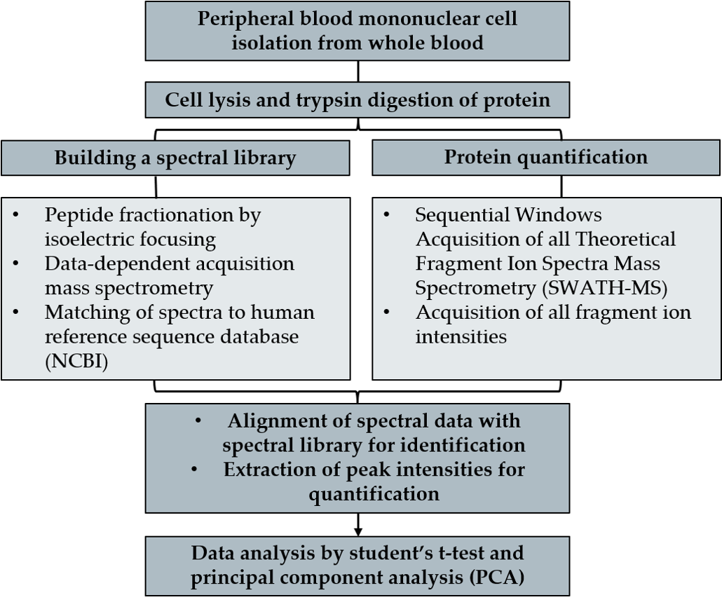

**Figure 1.** Schematic diagram of the SWATH-MS experimental protocol.

At the outset, a t-test comparison of the patient group vs the control group was carried out and proteins with significantly different relative abundances of P< 0.01 and log10(fold change) > 0.2 and < -0.2 identified (Tables 2 and 3). A total of 66 proteins were identified with different relative abundances between the eleven ME/CFS subjects and nine matched controls, with 36 showing increased relative abundance and 30 decreased relative abundance (P < 0.01, log10(fold-change) > 0.2 and < -0.2) (Table 2 (increased) and Table 3 (decreased)).

**Table 2:** Proteins with increased relative abundance in ME/CFS compared to healthy controls (*P* < 0.01, Log10(Fold Change) > 0.2)

|  |  |  |  |  |  |
| --- | --- | --- | --- | --- | --- |
| **GI Accession** | **Protein name** | **Gene name** | ***P*-value** | **Log10**  **(Fold Change)** | **Fold Change** |
| 22538467 | proteasome subunit beta type 4 | PSMB4 | 0.0002 | 0.2484 | 1.77 |
| 148727341 | serine-threonine kinase receptor-associated protein | STRAP | 0.0003 | 0.2081 | 1.61 |
| 145275202 | isoaspartyl peptidase/L-asparaginase | ASRGL1 | 0.0004 | 0.2079 | 1.61 |
| 24371248 | FUN14 domain-containing protein 2 | FUNDC2 | 0.0006 | 0.2545 | 1.80 |
| 41281564 | WD repeat-containing protein 37 | WDR37 | 0.0007 | 0.2283 | 1.69 |
| 148539872 | acetyl-CoA acetyltransferase, cytosolic | ACAT2 | 0.0009 | 0.2082 | 1.62 |
| 7705558 | inositol-3-phosphate synthase 1 isoform 1 | ISYNA1 | 0.0014 | 0.2420 | 1.75 |
| 44680136 | D-beta-hydroxybutyrate dehydrogenase, mitochondrial precursor | BDH1 | 0.0014 | 0.4147 | 2.60 |
| 4503165 | cullin-3 isoform 1 | CUL3 | 0.0015 | 0.4465 | 2.80 |
| 7019419 | nucleolar GTP-binding protein 2 | GNL2 | 0.0017 | 0.3764 | 2.38 |
| 6912388 | grancalcin | GCA | 0.0023 | 0.2524 | 1.79 |
| 4502205 | ADP-ribosylation factor 4 | ARF4 | 0.0023 | 0.2703 | 1.86 |
| 4506923 | SH2 domain-containing protein 1A isoform 1 | SH2D1A | 0.0027 | 0.2783 | 1.90 |
| 259155315 | mitochondrial 2-oxoglutarate/malate carrier protein isoform 2 | SLC25A11 | 0.0027 | 0.2376 | 1.73 |
| 115270970 | chloride channel CLIC-like protein 1 isoform 1 precursor | CLCC1 | 0.0030 | 0.2415 | 1.74 |
| 13129110 | methylosome protein 50 | WDR77 | 0.0031 | 0.2433 | 1.75 |
| 5031981 | 26S proteasome non-ATPase regulatory subunit 14 | PSMD14 | 0.0036 | 0.3210 | 2.09 |
| 188219591 | nucleolysin TIA-1 isoform p40 isoform 2 | TIA1 | 0.0037 | 0.2667 | 1.85 |
| 22035672 | thioredoxin reductase 2, mitochondrial precursor | TXNRD2 | 0.0039 | 0.3391 | 2.18 |
| 5454166 | vesicle transport through interaction with t-SNAREs homolog 1B | VTI1B | 0.0041 | 0.2863 | 1.93 |
| 7657116 | glyceraldehyde-3-phosphate dehydrogenase, testis-specific | GAPDHS | 0.0041 | 0.3476 | 2.23 |
| 169160905 | nuclear transport factor 2 | NUTF2 | 0.0042 | 0.3953 | 2.48 |
| 28373194 | proteasomal ubiquitin receptor ADRM1 precursor | ADRM1 | 0.0045 | 0.4295 | 2.69 |
| 225543288 | SUMO-activating enzyme subunit 1 isoform c | SAE1 | 0.0047 | 0.2545 | 1.80 |
| 47132595 | phosphate carrier protein, mitochondrial isoform b precursor | SLC25A3 | 0.0047 | 0.3204 | 2.09 |
| 4505023 | proteasome assembly chaperone 1 isoform a | PSMG1 | 0.0052 | 0.4901 | 3.09 |
| 300360515 | actin-related protein 2/3 complex subunit 1A isoform 2 | ARPC1A | 0.0052 | 0.2339 | 1.71 |
| 153251272 | calcineurin-like phosphoesterase domain-containing protein 1 isoform b | CPPED1 | 0.0053 | 0.2062 | 1.61 |
| 183396804 | regulation of nuclear pre-mRNA domain-containing protein 2 | RPRD2 | 0.0060 | 0.3549 | 2.26 |
| 48762926 | periodic tryptophan protein 2 homolog | PWP2 | 0.0065 | 0.3619 | 2.30 |
| 4885375 | histone H1.2 | H1-2 | 0.0075 | 0.2528 | 1.79 |
| 15487670 | nuclear RNA export factor 1 isoform 1 | NXF1 | 0.0081 | 0.2079 | 1.61 |
| 4885373 | histone H1.1 | H1-1 | 0.0083 | 0.2890 | 1.95 |
| 5032087 | splicing factor 3A subunit 1 isoform 1 | SF3A1 | 0.0089 | 0.2025 | 1.59 |
| 4885379 | histone H1.4 | H1-4 | 0.0089 | 0.2417 | 1.70 |
| 4885377 | histone H1.3 | H1-3 | 0.0094 | 0.2622 | 1.83 |

**Table 3:** Proteins with decreased relative abundance in ME/CFS compared to healthy controls (*P* < 0.01, Log10(Fold Change) < -0.2).

|  |  |  |  |  |  |
| --- | --- | --- | --- | --- | --- |
| **GI Accession** | **Protein name** | **Gene name** | ***P*-**  **value** | **Log10 (Fold Change)** | **Fold Change** |
| 7706495 | dnaJ homolog subfamily B member 11 precursor | DNAJB11 | 0.0003 | -0.2442 | 0.57 |
| 34101286 | zinc finger RNA-binding protein | ZFR | 0.0005 | -0.2826 | 0.52 |
| 6715607 | hemoglobin subunit gamma-2 | HBG2 | 0.0006 | -0.5105 | 0.31 |
| 8923541 | UPF0587 protein C1orf123 | C1orf123 | 0.0006 | -0.4569 | 0.35 |
| 4557367 | bleomycin hydrolase | BLMH | 0.0006 | -0.3634 | 0.43 |
| 66933005 | calnexin precursor | CANX | 0.0007 | -0.2362 | 0.58 |
| 14149916 | src-like-adapter 2 isoform a | SLA2 | 0.0007 | -0.2340 | 0.58 |
| 5031977 | nicotinamide phosphoribosyltransferase precursor | NAMPT | 0.0009 | -0.3093 | 0.49 |
| 19913385 | protein G6b isoform G6b-G precursor | C6orf25 | 0.0013 | -0.4151 | 0.38 |
| 143770741 | platelet glycoprotein VI isoform 1 precursor | GP6 | 0.0024 | -0.2114 | 0.61 |
| 10863927 | peptidyl-prolyl cis-trans isomerase A | PPIA | 0.0035 | -0.2639 | 0.54 |
| 4504351 | hemoglobin subunit delta | HBD | 0.0037 | -0.3260 | 0.47 |
| 4507171 | SPARC precursor | SPARC | 0.0040 | -0.5362 | 0.29 |
| 153082722 | intercellular adhesion molecule 2 precursor | ICAM2 | 0.0041 | -0.3653 | 0.43 |
| 4504073 | platelet glycoprotein Ib beta chain precursor | GP1BB | 0.0042 | -0.2578 | 0.55 |
| 12545406 | ras GTPase-activating protein 1 isoform 2 | RASA1 | 0.0047 | -0.2021 | 0.63 |
| 4506085 | mitogen-activated protein kinase 13 | MAPK13 | 0.0048 | -0.2703 | 0.54 |
| 157738645 | plexin-A4 isoform 1 precursor | PLXNA4 | 0.0051 | -0.3777 | 0.42 |
| 4504077 | platelet glycoprotein IX precursor | GP9 | 0.0060 | -0.3093 | 0.49 |
| 410173533 | PREDICTED: uncharacterized protein LOC100996504 | ENSG000  00263264 | 0.0076 | -0.2706 | 0.54 |
| 38348436 | carbonic anhydrase 13 | CA13 | 0.0076 | -0.3339 | 0.46 |
| 4757774 | ADP-ribosylation factor-like protein 3 | ARL3 | 0.0076 | -0.2382 | 0.58 |
| 155030185 | protein asunder homolog | ASUN | 0.0079 | -0.4425 | 0.36 |
| 190014603 | TBC1 domain family member 13 | TBC1D13 | 0.0080 | -0.2597 | 0.55 |
| 5032193 | TNF receptor-associated factor 1 isoform a | TRAF1 | 0.0081 | -0.3585 | 0.44 |
| 11386157 | cytidine deaminase | CDA | 0.0084 | -0.3146 | 0.48 |
| 171460997 | CD226 antigen precursor | CD226 | 0.0085 | -0.3163 | 0.48 |
| 164519136 | endothelin-converting enzyme 1 isoform 3 | ECE1 | 0.0085 | -0.2269 | 0.59 |
| 4758756 | nucleosome assembly protein 1-like 1 | NAP1L1 | 0.0090 | -0.3727 | 0.42 |
| 4758460 | platelet glycoprotein V precursor | GP5 | 0.0093 | -0.2859 | 0.52 |

The identified proteins were investigated by web-based applications STRING (http://string-db.org, version 11) and the Database for Annotation, Visualization and Integrated Discovery (DAVID) (https://david.ncifcrf.gov/, version 6.8). The increased abundance proteins have 24 functional assocations (CI > 0.4) compared to an expected number of 10 random interactions, and a PPI enrichment *P* = 0.00022 (see supplementary table S1). The decreased relative abundance proteins have 9 functional associations (CI > 0.4) compared to an expected number of 2 random interactions, and a PPI-enrichment *P* = 0.00068 (see supplementary table S1). Supplementary tables S2 and S3 show the biological processes, molecular functions and cellular components (GO annotations) involving the proteins identified as changed in the ME/CFS group. KEGG and Reactome pathways, UniProt keywords and PFAM, INTERPRO and SMART protein domains implicated by the differently abundant proteins are also shown. In summary, the increased abundance proteins in ME/CFS function in histone methylation, proteasome assembly, NAD, NAD(P)-binding and mitochondrial substrate/solute transport, and NF-ĸß activation, while decreased abundance proteins were primarily linked to wound healing, platelet activation and adhesion, blood coagulation and oxygen transport roles.

As the analysis was exploratory and, as has been shown in numerous studies of ME/CFS patient cohorts, it was likely there would be subgroups within the cohort, a principal component analysis (PCA) was used to further investigate the proteomes of the patient and control groups and to inform groupings. The identified principal components accounted for as much of the variability of the data as possible (PC1 30.5% of the data and PC2 17.5%), while having an orthogonal relationship. The PCA analysis confirmed no bias was introduced into the data by the order in which samples were measured. The PCA showed two distinct clusters of study samples with similar proteome expression patterns; one cluster included seven ME/CFS patients (P2, P3, P4, P5, P6, P8, and P9), now called the ‘ME/CFS’ group, while the second cluster included all nine control participants, the PCA ‘control’ group (Figure 2).



**Figure 2:** Principal component analysis of the study group proteomic data. Scores for PC1 (30.5%) versus PC2 (17.5%), Sqrt/Pareto. The nine age- and gender-matched healthy control subjects clustered close together, distinct from a large subgroup of seven (P2, P3, P4, P5, P6, P8, and P9, circled) of the eleven ME/CFS subjects.

A subgroup of four ME/CFS patients clustered after the PCA closer to the ‘control’ group. They were termed ‘a minor subgroup’. These four ME/CFS participants (P1, P7, P10 and P11) included both patients whose illness were a result of the Epstein Barr virus and from other causes. They exhibited similar protein expression PC1 and PC2 scores in the PCA, and grouped more closely with the control participants, and in particular to their matched healthy controls (P1 and C7, P7 and C8, P10 and C6, P11 and C2). The two different ME/CFS subgroups and control PCA clusters observed could not be explained by age, gender or BMI differences.

The previously proposed existence of subgroups within the overarching diagnosis of ME/CFS [9] could provide a possible explanation for the heterogeneity of the ME/CFS proteome seen in the PCA. Patients in our study might be further differentiated by their differing severity of symptoms experienced by individuals, resulting in subtly different disease biology [9,37]. With better clarification of ME/CFS pathology and diagnosis, these four ‘outlier’ ME/CFS participants in our study may fall into a different subgroup still within the disease definition than the seven ME/CFS participants; they do not have the same proteome expression patterns in comparison to the major PCA ME/CFS subgroup. Given the difficulties of making a diagnosis in this disease however, these four ME/CFS participants may have as-yet-unknown co-morbidities that distinguish them from the ME/CFS cohort or alternatively be simply a misdiagnosis because of the overlapping symptoms of fatigue syndromes [10]. Until our understanding of ME/CFS is more complete and a molecular diagnostic test is available, it is difficult to resolve better the concept of subgroups of ME/CFS.

The subgroup of seven ME/CFS patients were then as well compared with the nine controls. . A student’s t-test was carried out between the two identified groups (seven ME/CFS patients vs nine controls), finding now an expanded number of 211 proteins with significantly different abundance levels between the ‘ME/CFS’ group and ‘control’ group (P < 0.01, log10(Fold Change) ≥ 0.2 and ≤ -0.2, increased proteins n = 87; decreased proteins n = 124). Of these, the majority were involved in mitochondrial functional pathways, immune and inflammatory pathways, oxidative stress response, proteasome activation and genetic modification. This expanded protein dataset is shown in supplementary table S4. The proteins involved in mitochondrial functioning, cycles, oxidative phosphorylation and redox signaling have been selected out and are listed in Table 4. The Table also includes increased and decreased relative abundance mitochondrial proteins identified by the PCA analysis, with a lower P < 0.05 and fold changes > 1.3 and < 0.75 (shown in gray) . With these less stringent P-value and fold change cut-offs, of citric acid (TCA) cycle proteins and regulation of reactive oxygen species (ROS) proteins were identified.

**Table 4:** Differentially abundant mitochondria-related in the ‘ME/CFS’ PCA group compared to the ‘control’ group, (including proteins with P between 0.01 and 0.05 and/or Fold-Change > 1.3 and < 0.75, shaded in grey).

|  |  |  |
| --- | --- | --- |
| **Increased relative abundance** | ***P*-**  **value** | **Fold Change** |
| D-beta-hydroxybutyrate dehydrogenase, mitochondrial precursor | 0.0004 | 2.93 |
| NADH dehydrogenase [ubiquinone] 1 beta subcomplex subunit 3 | 0.0005 | 1.65 |
| FUN14 domain-containing protein 2 | 0.0011 | 1.85 |
| glycerol-3-phosphate dehydrogenase, mitochondrial precursor | 0.0021 | 1.53 |
| NADH dehydrogenase [ubiquinone] 1 beta subcomplex subunit 11, mitochondrial isoform 2 | 0.0036 | 1.79 |
| thioredoxin-related transmembrane protein 1 (TMX1) | 0.0045 | 1.33 |
| phosphate carrier protein, mitochondrial isoform b precursor | 0.0055 | 2.30 |
| NADH dehydrogenase [ubiquinone] 1 alpha subcomplex subunit 3 | 0.0064 | 1.70 |
| glyceraldehyde-3-phosphate dehydrogenase, testis-specific | 0.0081 | 2.37 |
| ATP synthase subunit delta, mitochondrial precursor | 0.0089 | 1.91 |
| ATP synthase subunit epsilon, mitochondrial | 0.0097 | 1.73 |
| histidine triad nucleotide-binding protein 2, mitochondrial precursor | 0.0098 | 1.34 |
| mitochondrial 2-oxoglutarate/malate carrier protein isoform 2 | 0.0101 | 1.78 |
| thioredoxin reductase 2, mitochondrial precursor | 0.0111 | 2.30 |
| peroxiredoxin-1 | 0.0118 | 1.47 |
| pyruvate dehydrogenase E1 component subunit beta, mitochondrial isoform 1 precursor | 0.0133 | 1.39 |
| mitochondrial fission 1 protein | 0.0141 | 1.60 |
| single-stranded DNA-binding protein, mitochondrial | 0.0149 | 1.58 |
| isocitrate dehydrogenase [NAD] subunit beta, mitochondrial isoform a precursor | 0.0151 | 2.45 |
| NADH dehydrogenase [ubiquinone] 1 alpha subcomplex subunit 12 isoform a | 0.0190 | 1.83 |
| diablo homolog, mitochondrial isoform 1 precursor | 0.0210 | 1.71 |
| mitochondrial antiviral-signaling protein isoform 1 | 0.0214 | 1.35 |
| mitochondrial import inner membrane translocase subunit TIM50 | 0.0241 | 6.94 |
| ATP synthase subunit b, mitochondrial precursor | 0.0251 | 1.58 |
| UMP-CMP kinase 2, mitochondrial isoform 1 precursor | 0.0273 | 2.15 |
| cytochrome c oxidase assembly factor 6 homolog isoform 1 | 0.0285 | 1.52 |
| stomatin-like protein 2, mitochondrial | 0.0285 | 1.40 |
| trifunctional enzyme subunit beta, mitochondrial precursor | 0.0316 | 1.44 |
| succinyl-CoA ligase [ADP-forming] subunit beta, mitochondrial precursor | 0.0340 | 1.34 |
| delta-1-pyrroline-5-carboxylate dehydrogenase, mitochondrial | 0.0344 | 1.52 |
| aconitate hydratase, mitochondrial | 0.0350 | 1.38 |
| peroxiredoxin-2 | 0.0371 | 1.37 |
| fumarate hydratase, mitochondrial | 0.0398 | 1.74 |
| heat shock protein 75 kDa, mitochondrial isoform 1 | 0.0400 | 1.33 |
| succinyl-CoA:3-ketoacid coenzyme A transferase, mitochondrial precursor | 0.0409 | 1.60 |
| **Decreased relative abundance** | ***P*- value** | **Fold Change** |
| Pisocitrate dehydrogenase [NADP], mitochondrial precursor | 0.00003 | 0.53 |
| ATP synthase mitochondrial F1 complex assembly factor 1 isoform 2 precursor | 0.0003 | 0.45 |
| cytochrome c | 0.0007 | 0.41 |
| mitochondrial import inner membrane translocase subunit Tim8 A isoform 1 | 0.0008 | 0.28 |
| peroxiredoxin-6 | 0.0015 | 0.57 |
| thioredoxin-dependent peroxide reductase, mitochondrial isoform a precursor | 0.0032 | 0.49 |
| cytochrome c1, heme protein, mitochondrial | 0.0052 | 0.63 |
| NADH dehydrogenase [ubiquinone] 1 alpha subcomplex subunit 5 | 0.0172 | 0.50 |
| glutathione S-transferase P | 0.0214 | 0.71 |
| ATP synthase subunit s, mitochondrial isoform a precursor | 0.0318 | 0.41 |

STRING analysis of the proteins increased (Figure 3**A)** and decreased (Figure 3**B** in the ME/CFS subgroup (n = 7) segregated by PCA complemented the findings from the initial full ME/CFS set (n = 11) when both were compared with the control group (n = 9). Overall, the functional associations of the differently abundant proteins of the subgroup of ME/CFS patients compared with nine controls increased significantly in each of the protein datasets, and the majority of the functional pathways identified when comparing all eleven ME/CFS participants with the control group were enriched by the PCA analysis. Additional proteasome-related proteins and several mitochondrial proteins involved in the electron transport chain and ATP synthesis emerged as now being highly enriched, while the histone methylation proteins were no longer significantly increased in the PCA ‘ME/CFS’ group. The decreased protein data set was expanded to include MHC class I immune proteins and ribosomal proteins. Figure 3**C**-**K** shows the key individual functional hubs identified in each protein data set. Specifically, *increased*: **C** mitochondrial proteins, **D** proteasome proteins, **E** immune proteins. *Decreased*: **F** antioxidant proteins, G translation proteins, **H** lysosomal proteins, **I** platelet activation oxygen transport proteins, **J** golgi proteins, **K** immune proteins.

Additional proteasome-related proteins and several mitochondrial proteins involved in the electron transport chain and ATP synthesis emerged as highly enriched, while the histone methylation proteins were no longer significantly increased in the PCA ‘ME/CFS’ group. The decreased protein data set was expanded to include MHC class I immune proteins and ribosomal proteins. The 87 increased proteins had 108 functional interactions (CI > 0.4) compared to the expected 59 random interactions, with a PPI enrichment *P* = 5.9 x 10-9. Similarly, the 123 decreased proteins (with one protein excluded as the sequence mapped to no known protein/gene) had 145 functional interactions (CI > 0.4) compared to 89 expected random interactions, with a PPI enrichment *P* = 3.86 x 10-8.

At a biological level, these results strongly implicate the presence of oxidative stress and the unfolded protein response (UPR) in ME/CFS PBMCs. Increases in respiratory chain complex proteins, in particular Complex I, the major producer of ROS in the mitochondria, identifies a probable source of high levels of ROS in the cells. Decreases in antioxidant proteins suggest a dampened response to oxidative stress in ME/CFS, and a reduced capacity to respond to such stress. The loss of the redox buffer to provide an oxidising environment for disulfide bond formation would thus result in protein misfolding in the ER. An initial response to ER stress is an attenuation of protein translation, indicated in our results by decreases in several proteins involved in the cellular translation machinery. Decreases in both golgi and lysosomal proteins are linked, with the golgi primarily responsible for lysosome production, and further support ER stress in the ME/CFS PBMCs. Misregulation of the ER-golgi interaction leads to further ER stress and the unfolded protein response. When the build-up of protein misfolding is beyond the capacity of the ER to cope, misfolded proteins are guided down endoplasmic reticulum-associated degradation (ERAD) and the ubiquitin-proteasome pathway. Proteasome protein increases are also seen, supporting increased flux through the ERAD pathway. Whether oxidative stress is driven by or results in an overactive immune/inflammatory response is yet to be determined, with significant dysregulation of the immune system seen in a plethora of increased and decreased immune proteins.

**Figure 3:** **A.** STRING functional interaction networks of the 87 proteins increased in abundance in the PCA ‘ME/CFS’ group compared to ‘controls’ (*P* < 0.01, Log10(Fold-Change) > 0.2) and in **B.** STRING functional interaction networks of the 123 proteins decreased in abundance in the PCA ‘ME/CFS’ group compared to ‘controls’ (*P* < 0.01, Log10(Fold-Change) < -0.2). **C**-**K.** shows the individual hubs (shown by location in **A**&**B** by these letters). *Increased*: **C**. mitochondrial, **D**. proteasome, **E**. immune. *Decreased*: **F.** antioxidant proteins, **G.** translation proteins, **H.** lysosomal proteins, **I.** platelet activation oxygen transport proteins, **J.** golgi proteins, **K.** immune proteins.

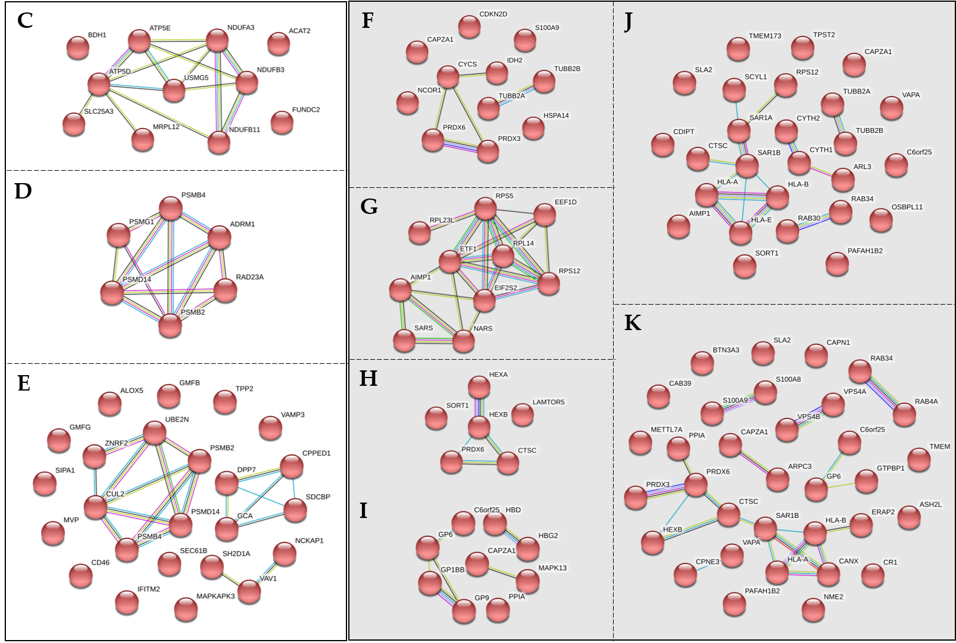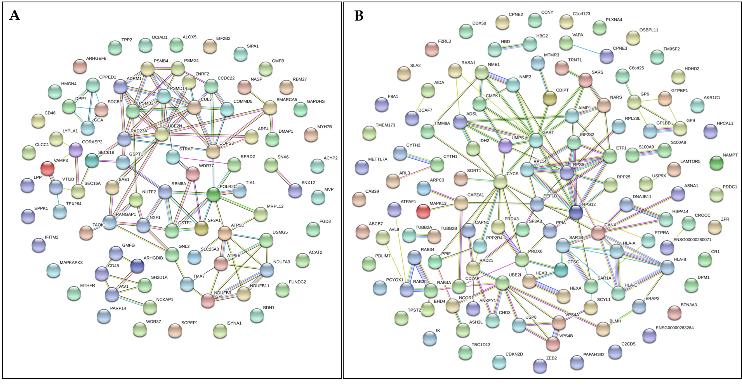

3.1.1 DAVID analysis

Protein data sets were submitted to DAVID for functional annotation clustering; the first being the significantly increased and decreased (P < 0.01, Log10(Fold Change) > 0.2 and < -0.2) proteins identified from a t-test comparison of both all eleven ME/CFS participants before PCA analysis and their nine matched controls, and the second the PCA selected subgroup of 7 patients and the nine controls all with medium confidence (CI > 0.4 combined score) or higher interactions (see Supplementary Table 1). Remarkably, even with the smaller number of proteins identified with different relative abundance in the full set of ME/CFS subjects in comparison to controls (increased n = 36 and decreased n = 30, Tables 1 and 2 respectively), several interesting biological pathways were either enriched (6 functional clusters) or depleted (4 functional clusters) in the ME/CFS group (see supplementary Figures S1 and S2 (increased proteins) and S3 (decreased proteins). Supporting the STRING analysis, histone methylation and regulation of gene expression was indicated to be an enriched biological implication of the increased protein data set. Also noted, WD repeat containing proteins were enriched, along with NAD and NAD(P)-binding Rossman-like fold proteins, proteins involved in proteasome poly-ubiquination of proteins and the MAPK cascade, inner membrane proteins of the mitochondrion, and proteins of the Golgi apparatus. Proteins decreased in the ME/CFS group were involved in blood coagulation and platelet activation, protein folding, neurological function and cell adhesion, including immunoglobulins.

The network of proteins with high confidence interactions (CI > 0.7 combined score, Supplementary Table 1) from a STRING analysis of increased and decreased abundance proteins (P < 0.01, Log10(Fold Change) > 0.2 and < -0.2) after t-test comparison of the PCA groups were also analysed by DAVID functional association clustering. The 44 increased proteins involved in high confidence PPI networks clustered into several key categories, specifically; mitochondria oxidative phosphorylation, Complex I assembly and NADH -> ubiquinone (enrichment score = 1.68); proteasome function, polyubiquination and the TNF-mediated signalling pathway (enrichment score = 2.09), ubiquitination (enrichment score = and mRNA processing and surveillance (enrichment score = 1.43). The 65 decreased proteins also clustered into functional groups including protein biosynthesis (enrichment score = 2.72); cell-cell adhesion (enrichment score = 2.4); golgi apparatus (enrichment score = 2.14); antigen processing and presentation, MHC class I and T cell mediated cytotoxicity (enrichment score = 1.82); and heme binding (enrichment score = 1.71).

An example of the David profile for the mitochondrial related proteins is shown in Figure 4.

**Figure 4:** Functional annotation cluster (enrichment score = 1.65) of mitochondria-related proteins, generated P < 0.01, Log10(Fold-Change) > 0.2). The enrichment score is the geometric mean (in -log scale) of protein member's P - values in their corresponding annotation cluster, and is used to rank biological significance, with the top ranked annotation groups having consistent lower p-values for their annotation members.

NADH:ubiquinone oxidoreductase subunit B11 (NDUFB11)

NADH:ubiquinone oxidoreductase subunit A3 (NDUFA3)

NADH:ubiquinone oxidoreductase subunit B3 (NDUFB3)

ATP synthase, H+ transporting, mitochondrial F1 complex, delta subunit (ATP5D)

ATP synthase, H+ transporting, mitochondrial F1 complex, epsilon subunit (ATP5E)

3-hydroxybutyrate dehydrogenase, type 1(BDH1)

solute carrier family 25 member 3 (SLC25A3)

mitochondrial ribosomal protein L12 (MRPL12)

up-regulated during skeletal muscle growth 5 homolog (USMG5)

acetyl-CoA acetyltransferase 2 (ACAT2)

RNA polymerase II subunit C (POLR2C)

methylenetetrahydrofolate reductase (MTHFR)

inositol-3-phosphate synthase 1(ISYNA1)

glyceraldehyde-3-phosphate dehydrogenase, spermatogenic (GAPDHS)

arachidonate 5-lipoxygenase (ALOX5)

acylphosphatase 2 (ACYP2)

FUN14 domain containing 2 (FUNDC2)

OCIA domain containing 1 (OCIAD1)

lysophospholipase I (LYPLA1)



Transit peptide:Mitochondrion

Transit peptide

GO:0005747~mitochondrial respiratory chain complex I

GO:0006120~mitochondrial electron transport, NADH to ubiquinone

Respiratory chain

GO:0032981~mitochondrial respiratory chain complex I assembly

R-HSA-6799198:Complex I biogenesis

Electron transport

R-HSA-611105:Respiratory electron transport

Hsa04932:Non-alcoholic fatty liver disease (NAFLD)

Hsa00190:Oxidative phosphorylation

hsa05012:Parkinson’s disease

hsa05010:Alzheimer’s disease

hsa05016:Huntington’s disease

GO:0005743~mitochondrial inner membrane

GO:0005739~mitochondrion

Mitochondrion inner membrane

Hsa01100:Metabolic pathways

Mitochondrion



Figure 4 shows positive associations between the proteins listed and biological and functional themes, clustering related proteins together and highlighting enriched pathways/functional groups. The five proteins involved in the respiratory china complex and oxidative phosphorylation (NDUFB11, NDUFA3, NDUFB3, ATP5D and ATP5E) are linked to several important biological pathways and, interestingly, neurodegenerative illnesses, and the remaining proteins clustered according to their more peripheral roles in the mitochondria.

**4. Discussion**

4.1. Evidence of mitochondrial dysfunction in this study

The most striking result from this proteome analysis was the number of different mitochondrial related proteins increased in expression in the ME/CFS group compared to controls, particularly after PCA grouping and analysis (Figure 3**A**). Several of these mitochondrial proteins were also increased when the full set of eleven ME/CFS participants were compared to the matched control subjects (Table 2). These included D-beta-hydroxybutyrate dehydrogenase (BDH1) and acetyl-CoA acetyltransferase containing 2 (ACAT2), both playing roles in fatty acid metabolism and the synthesis and degradation of ketone bodies. Mitochondrial 2-oxoglutarate/malate carrier protein isoform 2 (SLC25A11), transporting 2-oxoglutarate across the inner mitochondrial membrane and playing a role in gluconeogenesis from lactate, maintaining mitochondrial fusion and fission, and the organization and morphology of the mitochondrial cristae [38], and phosphate carrier protein, mitochondrial isoform b (SLC25A3), transporting phosphate into the mitochondria for oxidative phosphorylation. And FUN14 domain containing 2 (FUNDC2), in the outer mitochondrial membrane, and thioredoxin reductase 2 (TXNRD2), involved in mitochondrial redox homeostasis were identified. Together, these changes suggest that in the ME/CFS group, mitochondrial activity may be elevated, perhaps to the point where harmful by products such as reactive oxygen species (ROS) might be taking effect.

The interesting functional roles of these proteins became clearer with the expanded protein dataset arising from the PCA analysis where the study subjects were sorted on proteome expression pattern similarity, rather than ME/CFS status and healthy control designations. Those ME/CFS subjects clearly differing from their matched controls in the PCA exhibited an increased number of mitochondrial proteins with changed relative abundance. Most significantly, important Complex I proteins, TCA cycle proteins, redox regulation proteins Complex III proteins and Complex V (ATP Synthase) proteins were present in significantly different (and primarily increased) amounts in ‘ME/CFS’ compared to ‘controls’ (Table 4). The results suggest that the majority subgroup of the studies ME/CFS patients have dysregulation of mitochondrial energy production components, seen by significant increases in several key Complex I proteins.

Many of the identified mitochondrial proteins increased in expression (see Figure 5) were involved in proper functioning of OXPHOS complex in the inner membrane of the mitochondrion. Of the OXPHOS complexes, Complex I and Complex V (ATP Synthase), had a significant number of their constituent proteins with increased expression compared to controls (NDUFA3, NDUFB3 and NDUB11 in Complex I, and ATP5E, ATP5D and USMG5 in Complex V). The ATP metabolic process, generation of precursor metabolites and energy, oxidative phosphorylation, redox homeostasis and increased recycling of NAD, possibly to enhance the supply of NADH to Complex I via the TCA cycle, were identified by both STRING and DAVID functional association analysis as enriched in the ME/CFS cohort. Additionally, Complex I biogenesis was identified as enriched. Interestingly, of the identified mitochondrial proteins with decreased in amount in the ME/CFS cohort, PRDX3 (mitochondrial) and PRDX6 (whole cell body), with roles in redox regulation, as well as a protein involved in assembly of the mitochondrion (TIMM8A) were implicated. Mitochondrial IDH2, also decreased in the ‘ME/CFS’ group, uses NADP(+) as an electron receptor to catalyze its forward oxidative decarboxylation reaction in cellular defense against oxidative damage [39]. Decreases in these important redox regulatory proteins implies there may be an inability to cope with high levels of ROS produced by the electron transport chain in ME/CFS.

**Figure 5:** **A.** A schematic of the mitochondrial respiratory chain constructed by the authors to highlight the OXPHOS complexes, the major reactive oxygen species (ROS) production sites, and the ATP Synthase complex relevant to the differential expression of mitochondria-related proteins in the ME/CFS group **B.** Highlighting most significantly differentially abundant proteins (P < 0.01, Log10(Fold Change) > 0.2 and < -0.2) involved in mitochondrial function and energy metabolism. The green arrow represents increased relative abundance, and red arrow decreased relative abundance, in the ‘ME/CFS’ PCA group compared to controls.

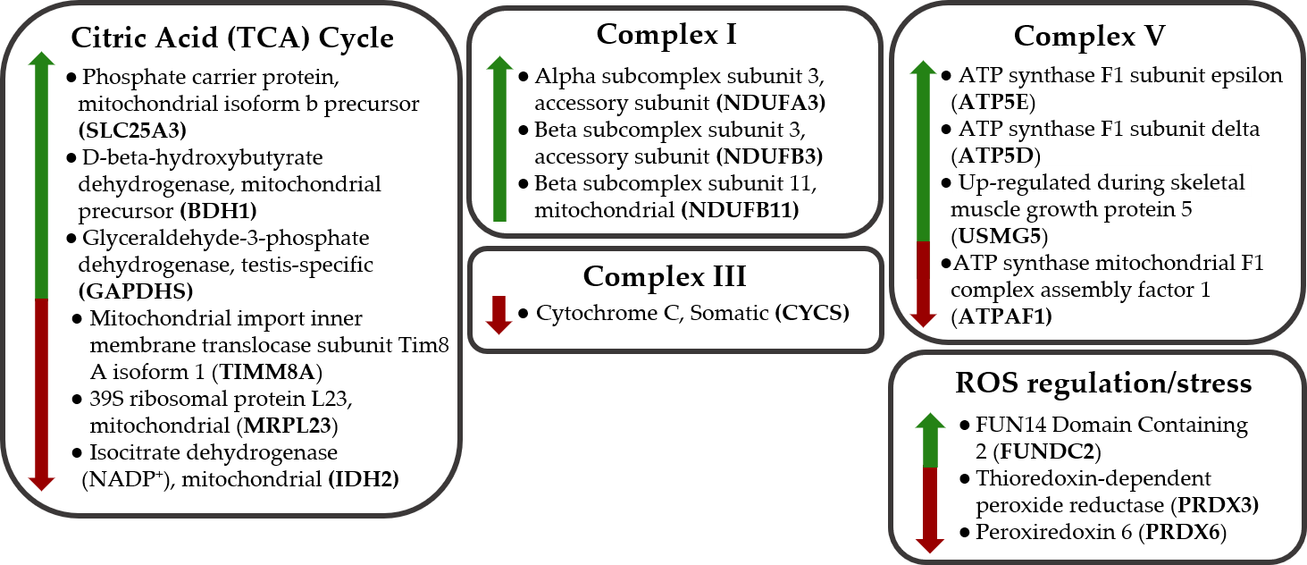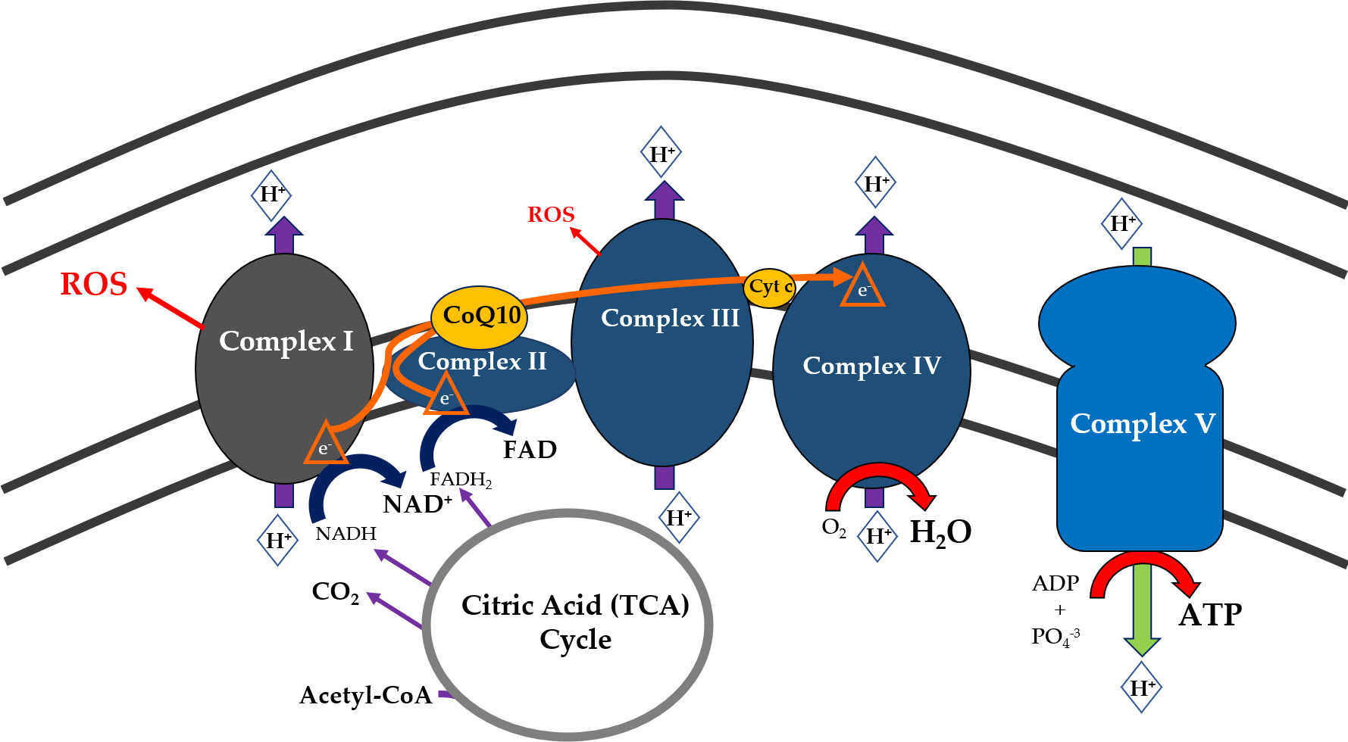

**B**

**A**

These findings suggest that in ME/CFS there are increased levels of Complex I and Complex V constituents, implying increased efforts to enhance ATP production in ME/CFS. As Complex I is the major producer of ROS in the electron transport chain, the identification of apparently dysregulated redox homeostasis in ME/CFS is important to note. In juxtaposition to the functional implications of the increased protein expression in the ME/CFS cohort, a key protein involved in ATP Synthase assembly (ATPAF1) was significantly decreased in expression, implying potential disruption of this complex. In future studies, it will be important to measure ATP levels and ROS production in PBMCs and other biological samples from the study group to corroborate these proteome findings. Dissecting mitochondrial function by Seahorse analysis (i.e. measuring oxygen consumption and extracellular acidification to determine the efficiency of different mitochondrial parameters, for example ATP production and maximal uncoupled respiration) would also be of interest.

4.2. Histone methylation and proteasome activation; dampened platelet activation and immune processes

Although differentially expressed mitochondria-related proteins are the main interest and focus of discussion in this paper, it is worth noting that significant changes were also observed between the ME/CFS cohort and control cohort in proteins involved in histone methylation, immune inflammation and proteasome activation functional networks (Table 2 and 3 and supplementary tables S2, S3 and S4). Histone methylation pathways highlighted by both STRING and DAVID analysis indicated histone methylation at H3K4 (activating nearby gene expression) and H3K27 (repression of gene expression). Differential methylation patterns have been observed in ME/CFS by us [40] and other research groups, many in immune-related genes, [41] Epigenetic modifications have been suggested to play important roles in inflammatory and autoimmune diseases, diseases which share many similarities with ME/CFS [42]. Multiple DNA methylation studies have now shown both hypo-methylation and hyper-methylation at specific gene promoters in ME/CFS patients, including in our own ongoing patient/control study. In our study, hyper-methylation changes were proportionally much higher at promoters than across the whole genome, where loss of methylation accounted for most of the changes between the ME/CFS study group and the controls [10]. The addition of methyl groups at promoters is consistent with a hypometabolic state where the expression of genes involved in metabolic pathways is down regulated. Differential methylation in ME/CFS has been found in close proximity to genes involved in immune function and cellular metabolism, linked with the ME/CFS phenotype [43,44,45]. Overall, these findings align with recent ME/CFS work pointing towards impairment in cellular energy production and immune dysfunction in the patient population. Several proteasome proteins were also increased in the proteomes of both the full set of ME/CFS subjects and the PCA selected ‘ME/CFS’ subgroup (Table 2 and supplementary Table S4). This apparent upregulation of the proteasome may be a response to misfolded proteins, a phenomenon also implicated in STRING and DAVID functional assessments, due to concurrent ROS damage and oxidative stress in ME/CFS PBMCS.

The observation of a dampening effect on platelet activation, and MHC class I immune functions, in ME/CFS is also of interest. Only surface platelet membrane glycoproteins were identified, along with activating factors, suggesting some platelet proteins remained in the PBMC fraction via interaction with them, and in higher amounts in controls than in ME/CFS. Activated platelets have an anti-inflammatory effect by interacting directly with monocytes via activating-type Fc receptors for IgG to enhance IL-10 production and reduce TNFα secretion [46]. It is also possible ME/CFS patients may have reduced platelets overall, or suppressed immune activation, that contributed to their lower abundance of platelet proteins. MHC Class I-related proteins were decreased in the ‘ME/CFS’ group. The function of this class of protein is to display intracellular peptides, generated mainly from degradation of cytosolic proteins by the proteasome to cytotoxic T cells. Interestingly proteasome activity and protein degradation does appear to be enhanced in the ME/CFS, suggesting the dampening down of the MHC Class I functional pathways may be a response to prevent unnecessary activation of the immune response. A transcriptome study of the same ME/CFS and control study group found among genes significantly differently expressed in ME/CFS, the three most significant and increased were IL8, NFKBIA and TNFAI3P, all functionally related as responders to over-activation of inflammatory NF-KB. STRING (P < 0.01) and ingenuity pathway analysis (P < 0.05) of the biological pathways affected by these changed genes including immune/inflammatory pathways, cellular stress response and oxidative stress, circadian clock function, metabolism and mitochondrial function [26]. The correlating gene transcripts encoding the respiratory complexes, TCA cycle proteins and ATP Synthase subunits were not noted to be significantly changed in the ME/CFS transcriptome, so may be regulated by post translational mechanisms to increase their proteins, however similar biological pathways were apparently enriched in both studies. Thus, these findings support the already substantial published evidence for immune dysregulation playing an important role in ME/CFS pathogenesis [47].

4.3. How this proteome analysis compares to other ME/CFS proteome analyses and mitochondrial dysfunction

Proteomic studies, although not by SWATH-MS analysis, in more recent years have implicated mitochondrial involvement in ME/CFS, but with conflicting evidence. One group found reduced mitochondria biogenesis, but not normalized respiratory chain enzyme activities in the muscle of ME/CFS sufferers [48]. Consistent with this study, the elevated expression of mitochondrial proteins in serum, platelets and lymphocytes have been found in some studies [27,49]. Conversely in others, mitochondrial function appeared reduced in isolated neutrophil cells, [28,29], as did respiration in ME/CFS PBMCs [50], while oxidative phosphorylation complexes appeared unaffected [30,31].

However, other studies have emerged recently implicating a significant role for mitochondrial dysfunction, consistent with the finding of this SWATH-MS study. An important study was a translational case–control study of monozygotic twins discordant for ME/CFS by Ciregia et al (2016) [28], who performed proteomics on platelet mitochondria. Of the 1007 proteins detected, 194 mitochondrial proteins were significantly different in ME/CFS. Among these, 41 had a fold change greater than 2.0 (34 upregulated and 7 downregulated). This study highlighted similar protein expression changes to the results presented from our PBMC proteome study and important biological pathways inferred to be affected were also found to be dysregulated in our SWATH-MS proteome study of the Dunedin ME/CFS cohort. For example, in the Cirega et al (2016) study pathway analysis highlighted the ‘metabolism of NADH’ as one of the most important biological functions involved in ME/CFS [28]. Our results implicate higher levels of NADH would be produced due to increased abundance in proteins in the TCA cycle, along with potentially increased oxidation of NADH by upregulated Complex I. The NAD+/NADH ratio has an important role in regulating the intracellular redox status and, therefore, represents the metabolic state. Some studies have suggested that NADH concentrations are by contrast significantly lower in ME/CFS patients compared with healthy controls [51,52]. Higher levels of malate dehydrogenase and isocitrate dehydrogenase were observed in the case-control study above and proposed to be an adaptive response to deficiencies of NADH which, in turn, would play a critical role in mitochondrial ATP production. Integrating the results of this study and our own, a plausible hypothesis is that there is metabolic dysfunction in ME/CFS resulting in insufficient energy production and triggering compensatory increases in key OXPHOS proteins to ameliorate this deficiency.

A recent paper provides significant and substantial support for this hypothesis [27]. This paper investigated immortalized lymphoblasts from 51 ME/CFS patients, assessing parameters of mitochondrial function by Seahorse extracellular flux analysis, proteomics, and biochemical assays. The most striking finding from these experiments was the observation that the rate of ATP synthesis by Complex V, as a proportion of basal oxygen consumption, was significantly reduced in ME/CFS [27]. Concurrently, significant elevations were seen in Complex I oxygen consumption rate (OCR), maximum OCR, spare respiratory capacity, non-mitochondrial OCR and “proton leak” as a proportion of basal OCR [27]. Also seen was upregulated expression of the mitochondrial respiratory complexes, fatty acid transporters and enzymes of the ß-oxidation and TCA cycles [27]. Together these findings support an illness model whereby a defect in Complex V, and therefore deficiency in ATP production, is accompanied by a compensatory upregulation of mitochondrial respiratory capacity and respiratory complexes, membrane transporters, and proteins involved in fatty acid ß-oxidation [27]. These compensatory mechanisms homeostatically enable adequate ATP synthesis in resting cells, however they will be unable to respond sufficiently to acute energy demands.

4.4.1. The key role of mitochondrial Complex I

The observation in our study, in Missailidis et al (2019) [27] and in Cirega et al (2016) [28] of significant increases in expression of Complex I proteins is worthy of further discussion. These key studies, and the proteome results presented here, strongly indicate oxidative damage is occurring in ME/CFS. Complex I is composed of 44 different subunits, and its assembly requires at least 13 specific assembly factors [53]. Complex I modular assembly depends on a tightly coordinated series of steps, with the different functional modules proposed to assemble separately and associate together afterwards to form the final enzyme [54]. Furthermore, Complex I is known to form supercomplexes with Complex III and IV in the inner mitochondrial membrane, helping to form the cristae folds within the mitochondrion, and directly affecting mitochondrial function and ATP synthesis [53]. Mitochondrial cristae are structured such that OXPHOS complexes are near one another, with Complex V (ATP Synthase) placed at the edge of the cristae with the other complexes located along both sides [55]. This strict shaping of the cristae appears to be fundamental for the creation of a proton gradient, with protons flowing from the complexes to the ATP Synthase [55]. Complex I is an L shaped molecule, with a peripheral arm that protrudes into the mitochondrial matrix, and a membrane arm that sits in the inner membrane [53]. The two functional blocks within the peripheral arm have been termed the N (NADH binding) and Q (ubiquinone binding) modules. The membrane arm consists of the P (proton pumping) module, which in turn has proximal and distal ends that form separately during Complex I assembly. The identified increased proteins are involved in the transmembrane module; NDUFA3 in the proximal portion of the P module; and NDUFB3, and NDUFB11 in the distal portion of the P module [53]. While the specific roles of many of the accessory subunits in Complex I are not yet known, it has been proposed that the eukaryotic supernumerary subunits assist in Complex I biogenesis and stability.

As Complex I is the major producer of reactive oxygen species (ROS) within the electron transport chain and thus a significant contributor to cellular oxidative stress. It is to be expected that an increase in ROS may be observed in conjunction with the increase in Complex I protein expression, as well as effects on enzymes involved in redox regulation and homeostasis [56]. Further, as Complex I is frequently found assembled as a supercomplex with Complex III and IV, and this has been proposed as a method of controlling ROS generation by Complex I [57,58]. The supercomplex acts to prevent excessive superoxide production during oxidation of NAD-linked substrates because the resulting efficient CoQ channeling helps to maintain the chain in the oxidized state [57]. This supercomplex formation relies on balanced stoichiometric ratios of each complex. Increased expression of Complex I subunits may then affect supercomplex organization, and in turn cause a dramatic enhancement of ROS production by Complex I [57].

Interestingly, in our study, while a key mitochondrial redox regulatory protein was increased in abundance, some important antioxidant proteins were observed to be decreased in the ME/CFS only cohort. This suggests that in ME/CFS there may in fact be a reduced ability to cope with oxidative stress upon the cells, potentially leading to oxidative damage and further pathogenesis. Complex I is also particularly sensitive to ROS damage [58], therefore the increased expression of several Complex I proteins may be a response to this damage. Perhaps an indication of defective ATP production by ME/CFS mitochondria, a 2016 ME/CFS study of ATP levels in PBMCs observed that ATP levels were higher and mitochondria cristae more condensed when compared to controls [32]. It was noted the increased ATP was largely from non-mitochondrial sources [32]. Perturbations in mitochondria-shaping proteins and disruption to supercomplex formation and thereby cristae structure have been implicated in various diseases, for example Parkinson’s disease [59]. Indeed, an analysis of the mitochondria-shaping proteins altered in the context of Parkinson’s disease (the vast majority of which were related to the organization of cristae) found many of their binding partners were related to the mitochondria and the proteasome [59]. Also sharing similarity with our ME/CFS findings, the mitochondria-shaping proteins altered in Parkinson’s disease are involved in biological pathways relating to the production and metabolism of ATP, immune response and oxidative stress [59].

Evidence is mounting that mitochondrial dysfunction plays a significant role in the pathogenesis of ME/CFS. Various studies including emerging proteome studies on a range of biological samples hold promise in uncovering the underlying pathology in complex illnesses such as ME/CFS. Whether any individual changes in protein expression, or combinations of proteins, could act as a diagnostic biomarker for ME/CFS remains to be seen, after further validation experiments are carried out with different ME/CFS cohorts, larger cohorts and with other similarly presenting illnesses. However, a model for deficient ATP production and resulting compensatory mechanisms has been developed [27] and corroborated by this study and others and provides a plausible explanation for the characteristic post-exertional malaise experienced in ME/CFS.

**Declarations:**

**Ethics approval and consent to participate:** The study had approvals from by Health and Disability Ethics Committees in New Zealand (NTY/12/06/055 and 15426). All participants gave written consent for the study.

**Consent for publication:** Not applicable.

**Availability of data and materials:** All data generated or analysed during this study are included in this published article [and its supplementary information files]. The full raw datasets analysed during the current study are available from the corresponding author on reasonable request.

#### Competing interests: The authors declare they have no competing interests.

**Funding:** This research was funded by the HJ & JC Anderson Trust, a University of Otago Research grant, the Association of ME Society (ANZMES) and, especially generous private donations.

**Author Contributions:** conceptualization, ES and WT.; methodology, ES, CE and TK.; validation, TK and ES.; formal analysis, ES, MdL and TK.; investigation, ES, CE, AM, WT.; resources, WT, RV and TK.; data curation, ES, MdL and TK.; writing—original draft preparation, ES and TK.; writing—review and editing, WT.; supervision, WT.; project administration, WT, RV.; funding acquisition, WT.

**Acknowledgments:** We express our gratitude for the support of our ME/CFS patient and control cohorts. We thank the National ME/CFS Disease Association – Associated New Zealand ME Society (ANZMES) – for their ongoing encouragement and support.

**Abbreviations**

|  |  |
| --- | --- |
| ME/CFS | Myalgic Encephalomyelitis/Chronic Fatigue Syndrome |
| GO | Gene Ontology |
| PC | Principal component |
| DDA | Data-dependent acquisition |
| DIA | Data-independent acquisition |
| SWATH-MS  LC  CCC  ROS  OXPHOS  ATP  PBMC  PPI | Sequential Windows Acquisition of all Theoretical Fragment Ion Spectra-mass spectrometry  Liquid chromatography  Canadian consensus criteria  Reactive oxygen species  Oxidative phosphorylation  Adenosine triphosphate  Peripheral blood mononuclear cells  Protein-protein interaction |

**References**

1. IOM (Institute of Medicine). Beyond Myalgic Encephalomyelitis/Chronic Fatigue Syndrome: Redefining an Illness. Washington (DC): National Academies Press (US), 2015.

2. Devanur, L.D.; Kerr, J.R. Chronic fatigue syndrome. J Clin Virol 2006, 37, 139-150.

3. Lorusso, L.; Mikhaylova, S.V.; Capelli, E.; Ferrari, D.; Ngonga, G.K.; Ricevuti, G. Immunological aspects of chronic fatigue syndrome. *Autoimmun Rev* **2009**, *8*, 287-291.

4. Carruthers, B.M.; van de Sande, M.I.; De Meirleir, K.L.; Klimas, N.G.; Broderick, G.; Mitchell, T.; Staines, D.; Powles, A.C.P.; Speight, N.; Vallings, R.; Bateman, L.; Baumgarten-Austrheim, B.; Bell, D.S.; Carlo-Stella, N.; Chia, J.; Darragh, A.; Jo, D.; Lewis, D.; Light, A.R.; Marshall-Gradisnik, S.; Mena, I.; Mikovits, J.A.; Miwa, K.; Murovska, M.; Pall, M.L.; Stevens, S. Myalgic encephalomyelitis: International Consensus Criteria. *J Intern Med* **2011**, *270*, 327-338.

5. Steinau, M.; Unger, E.R.; Vernon, S.D.; Jones, J.F.; Rejeevan, M.S. Differential-display PCR of peripheral blood for biomarker discovery in chronic fatigue syndrome. J Mol Med 2004, 82, 750-755.

6. Bansal, A.S.; Bradley, A.S.; Bishop, K.N.; Kiani-Alikhan, S.; Ford, B. Chronic fatigue syndrome, the immune system and viral infection. *Brain Behav Immun* **2012**, *26*, 24-31.

7. Moldofsky, H.; Patcai, J. Chronic widespread musculoskeletal pain, fatigue, depression and disordered sleep in chronic post-SARS syndrome; a case-controlled study. *BMC Neurol* **2011**, *11***,**37-43.

8. Holgate, S.T.; Komaroff, A.L.; Mangan, D.; Wessely, S. Chronic fatigue syndrome: understanding a complex illness. *Nature Rev Neurosci* **2011**, *12*, 539-544.

9. Siegel, S.D.; Antoni, M.H.; Fletcher, M.A.; Maher, K.; Segota, M.C.; Klimas, N. Impaired natural immunity, cognitive dysfunction, and physical symptoms in patients with chronic fatigue syndrome: preliminary evidence for a subgroup? *J Psychosom Res* **2006**, *60*, 559-566.

10. Sweetman, E.C.; Noble, A.; Edgar, C.; Mackay, A.; Halliwell, A.; Vallings, R.; Ryan, M.; Tate, W.P. Current research provides insight into the biological basis and diagnostic potential for myalgic encephalomyelitis/chronic fatigue syndrome (ME/CFS). *Diagnostics* **2019**, *9*, 73-96.

11. Mackay, A.; Tate, W.P. A compromised paraventricular nucleus within a dysfunctional hypothalamus: A novel neuroinflammatory paradigm for ME/CFS. *Int J Immunopathol Pharmacol* **2018**, *32*, 1-8.

12. Montoya, J.G.; Holmes, T.H.; Anderson, J.N.; Maeker, H.T.; Rosenberg-Hasson, Y.; Valencia, L.C.; Younger, J.W.; Tato, C.M.; Davis, M.M. Cytokine signature associated with disease severity in chronic fatigue syndrome patients. *Proc Natl Acad Sci USA* **2017**, *114*, E7150-E7158.

13. Naviaux, R.K.; Naviaux, J.C.; Li, K.; Bright, A.T.; Alaynick, W.A.; Wang, L.; Baxter, A.; Nathan, N.; Anderson, W.; Gordon, E. Metabolic features of chronic fatigue syndrome. *Proc Nat Acad Sci USA* **2016**, *113*, E5472-E5480.

14. Fluge, O.; Mella, O.; Bruland, O.; Risa, K.; Dyrstad, S.E.; Alme, K.; Rekeland, I.G.; Sapkota, D.; Rosland, G.V.; Fossa, A.; Ktoridou-Valen, I.; Lunde, S.; Sorland, K.; Lien, K.; Herder, I.; Thurmer, H.; Gotaas, M.E.; Baranowska, K.A.; Bohnen, L.M.L.J.; Schafer, C.; McCann, A.; Sommerfelt, K.; Helgeland, L.; Ueland, P.M.; Dahl, O.; Tronstad, K.J.et al. Metabolic profiling indicates impaired pyruvate dehydrogenase function in myalgic encephalopathy/chronic fatigue syndrome. *JCI Insight* **2016**, *1*, e89376.

15. Tomas, C.; Brown, A.; Strassheim, V.; Elson, J.; Newton, J.; Manning, P. Cellular bioenergetics is impaired in patients with chronic fatigue syndrome. *PLoS One* **2017**, *12*, e0186802.

16. Armstrong, C.W.; McGregor, N.R.; Lewis, D.P.; Vernon, S.D.; Le, T.; Clevidence, D.; Robertson, C.E.; Schrodi, S.J.; Yale, S.; Frank, D.N. Metabolic profiling reveals anomalous energy metabolism and oxidative stress pathways in chronic fatigue syndrome patients. Metabolomics 2015; 11: 1626-1639.

17. Shukla, S.K.; Cook, D.; Meyer, J.; Changes in gut and plasma microbiome following exercise challenge in myalgic encephalomyelitis/chronic fatigue syndrome (ME/CFS). *PLoS One* **2015**, *10*, e0145453.

18. Mandarano, A.H.; Giloteaux, L.; Keller, B.A.; Levine, S.M.; Hanson, M.R. Eukaryotes in the gut microbiota in myalgic encephalomyelitis/chronic fatigue syndrome. *PeerJ* **2018**, *6*, e4282.

19. Giloteaux, L.; Goodrich, J.K.; Walters, W.A.; Levine, S.M.; Ley, R.E.; Hanson, M.R. Reduced diversity and altered composition of the gut microbiome in individuals with myalgic encephalomyelitis/chronic fatigue syndrome. *Microbiome* **2016**, *4*, 30-41.

20. de Vega, W.C.; Erdman, L.; Vernon, S.D.; Goldenberg, A.; McGowan, P.O. Integration of DNA methylation and health scores identifies subtypes in myalgic encephalomyelitis/chronic fatigue syndrome. *Epigenomics* **2018**, *10*, 539-557.

21. Herrera, S.; de Vega, W.C.; Ashbrook, D.; Vernon, S.D.; McGowan, P.O. Genome-epigenome interactions associated with myalgic encephalomyelitis/chronic fatigue syndrome. *Epigenetics* **2018**, *5*, 1-17.

22. de Vega, W.C.; Vernon, S.D.; McGowan, P.O. DNA methylation modifications associated with chronic fatigue syndrome. *PLoS One* **2014**, *9*, e104757.

23. Brenu, E.W.; Staines, D.R.; Marshall-Gradisnik, S. Methylation profile of CD4+ T cells in chronic fatigue syndrome/myalgic encephalomyelitis. *J Clin Cell Immunol* **2014**, *5*, 228-241.

24. Nguyen, C.B.; Alsøe, L.; Lindvall, J.M.; Sulheim, D.; Fagermoen, E.; Winger, A.; Kaarbo, M.; Nilsen, H.; Wyller, V.B. Whole blood gene expression in adolescent chronic fatigue syndrome: an exploratory cross-sectional study suggesting altered B cell differentiation and survival. *J Trans Med* **2017**, *15*, 102-122.

25. Bouquet, J.; Gardy, J.L.; Brown, S.; Pfiel, J.; Miller, R.R.; Morshed, M.; Avina-Zubieta, A.; Shojania, K.; McCabe, M.; Parker, S.; Uyaguari, M.; Federman, S.; Tang, P.; Steiner, T.; Otterstater, M.; Holt, R.; Moore, R.; Chiu, C.Y.; Patrick, D.M.; Complex Chronic Disease Study Group. RNA-seq analysis of gene expression, viral pathogen, and B-cell/T-cell receptor signatures in complex chronic disease. *Clinical Infectious Diseases: An Official Publication of the Infectious Diseases Society of America* **2017**, *64*, 476-481.

26. Sweetman, E.C.; Noble, A.; Edgar, C.; Mackay, A.; Halliwell, A.; Vallings, R.; Ryan, M.; Tate, W.P. Changes in the transcriptome of circulating immune cells of a New Zealand cohort with Myalgic encephalomyelitis/Chronic Fatigue Syndrome. *Int J Immunopathol Pharmacol* **2019**, *33*, 1-8.

27. Missailidis, D; Annesley, S.J.; Allan, C.Y.; Sanislav, O.; Lidbury, B.A.; Lewis, D.P.; Fisher, P.R. An isolated complex V inefficiency and dysregulated mitochondrial function in immortalized lymphocytes from ME/CFS patients. *Int J Mol Sci* **2020**, *21*, 1074.

28. Ciregia, F.; Kollipara, L.; Giusti, L.; Zahedi, R.P.; Giacomelli, C.; Mazzoni, M.R.; Giannaccini, G.; Scarpellini, P.; Urbani, A.; Sickmann, A.; Bottom-up proteomics suggests an association between differential expression of mitochondrial proteins and chronic fatigue syndrome. *Transl Psychiatry* **2016**, *6*, e904.

29. Myhill, S.; Booth, N.E.; McLaren-Howard, J. Chronic fatigue syndrome and mitochondrial dysfunction. *Int J Clin Exp Med* **2009**, *2*, 1-16.

30. Booth, N.E.; Myhill, S.; McLaren-Howard, J. Mitochondrial dysfunction and the pathophysiology of myalgic encephalomyelitis/chronic fatigue syndrome (ME/CFS). *Int J Clin Exp Med* **2012**, *5*, 208-220.

31. Vermeulen, R.C.; Kurk, R.M; Visser, F.C.; Sluiter, W.; Scholte, H.R. Patients with chronic fatigue syndrome performed worse than controls in a controlled repeated exercise study despite a normal oxidative phosphorylation capacity. *J Transl Med* **2010**, *8,* 93.

32. Lawson, N.; Hseih, C.; March, D.; Wang, X. Elevated energy production in chronic fatigue syndrome patients. *J Nat Sci* **2016**, *2*, e221.

33. Newman, S.K.; Jayanthan, R.K.; Mitchell, G.W.; Tartak, J.A.C.; Croglio, M.P.; Suarez, A.; Liu, A.Y.; Razzo, B.M.; Oyeniran, E.; Ruth, J.R.; Fajgenbaum, D.C. Taking Control of Castleman Disease: Leveraging Precision Medicine Technologies to Accelerate Rare Disease Research. *Yale J Biol Med* **2015**, *88*, 383-388.

34. Aebersold, R; Mann, M. Mass-spectrometric exploration of proteome structure and function. Nature 2016, 537, 347-355.

35. Carruthers, B.M.; Kumar, J.A.; de Meirleir, K.L.; Klimas, N.G.; Broderick, G.; Mitchell, T.; Staines, D.; Powles, A.C.P.; Speight, N.; Vallings, R.; Bateman, L.; Baumgarten-Austrheim, B.; Bell, D.S.; Carlo-Stella, N.; Chia, J.; Darragh, A.; Jo, D.; Lewis, D.; Light, A.R.; Marshall-Gradisnik, S.; Mena, I.; Mikovits, J.A.; Miwa, K.; Murovska, M.; Pall, M.L.; Stevens, S. Myalgic Encephalomyelitis/Chronic Fatigue Syndrome: Clinical Working Case Definition, Diagnostic and Treatment Guidelines, A Consensus Document. J Chronic Fatigue Syndr 2003; 11: 7-115.

36. Wiśniewski, J. R. Filter-aided sample preparation: the versatile and efficient method for proteomic analysis. Method Enzymol 2017, 585, 15-27.

37. Jason, L.A.; Boulton, A.; Porter, N.S.; Jessen, T.; Njoku, M.G. Classification of myalgic encephalomyelitis/chronic fatigue syndrome by types of fatigue. Behav Med 2010, 36, 24-31.

38. Gallo, M.; Park, D.; Luciani, D.S.; Kida, K.; Palmieri, F.; Blacquw, O.E.; Johnson, J.D.; Riddle, D.L. MISC-1/OGC links mitochondrial metabolism, apoptosis and insulin secretion. PLos One 2011, 6, e17827.

39. Al-Khallaf, H. Isocitrate dehydrogenases in physiology and cancer: biochemical and molecular insight. Cell Biosci 2017, 7, 37-54.

40. Helliwell AM. An Epigenetic Analysis of Myalgic Encephalomyelitis/Chronic Fatigue Syndrome. MSc thesis University of Otago 2020 pp1-210.

41. Trivedi MS, Oltra E, Sarria L, Rose N, Beljanski V, Fletcher MA, et al. (2018) Identification of Myalgic Encephalomyelitis/Chronic Fatigue Syndrome-associated DNA methylation patterns. PLoS ONE 13(7): e0201066.

42. de Vega, W.C.; Erdman, L.; Vernon, S.D.; et al. Integration of DNA methylation and health scores identifies subtypes in myalgic encephalomyelitis/chronic fatigue syndrome. *Epigenomics* **2018**; *10*: 539-557.

43. de Vega, W.C.; Herrera, S.; Vernon, S.D.; McGowan, P.O. Epigenetic modifications and glucocorticoid sensitivity in myalgic encephalomyelitis/chronic fatigue syndrome. *BMC Med Genomics* **2017**; *10*: 11-24.,

44. Herrera, S.; de Vega, W.C.; Ashbrook, D.; et al. Genome-epigenome interactions associated with myalgic encephalomyelitis/chronic fatigue syndrome. *Epigenetics* **2018**; *5*: 1-17.,

45. de Vega, W.C.; Vernon, S.D.; McGowan, P.O. DNA methylation modifications associated with chronic fatigue syndrome. *PLoS One* **2014**; *9*: e104757.

46. Inui, M., Tazawa, K., Kishi, Y., and Takai, T. (2015). Platelets convert peripheral blood circulating monocytes to regulatory cells via immunoglobulin G and activating-type Fcgamma receptors. BMC Immunology *16*, 20.

47. Sotzny, F.; Blanco, J.; Capelli, E.; Castro-Marrero, J.; Steiner, S.; Murovska, M.; Scheibenbogen, C.; European Network on ME/CFS (EUROMENE). Myalgic encephalomyelitis/chronic fatigue syndrome – evidence for an autoimmune disease. Autoimmun Rev 2018, 17, 601-609.

48. Smits, B.; van den Heuvel, L.; Knoop, H.; Kusters, B.; Janssen, A.; Borm, G.; Bleijenberg, G.; Rodenburg, R.; van Engelen, B. Mitochondrial enzymes discriminate between mitochondrial disorders and chronic fatigue syndrome. Mitochondrion 2011, 11, 735-738.

49. Kaushik, N.; Fear, D.; Richards, S.C.; McDermott, C.R.; Nuwaysir, E.F.; Kellam, P.; Harrison, T.J.; Wilkinson, R.J.; Tyrrell, D.A.; Holgate, S.T.; Kerr, J.R. Gene expression in peripheral blood mononuclear cells from patients with chronic fatigue syndrome. J Clin Pathol 2005, 58, 826-832.

50. Tomas, C.; Brown, A.; Strassheim, V;Elson, J.; Newton, J.; Manning, P. Cellular bioenergetics is impaired in patients with chronic fatigue syndrome. PLoS One 2017, 12, e0186802.

51. Mikirova, N; Casciari, J.; Hinninghake, R.; The assessment of the energy metabolism in patients with chronic fatigue syndrome by serum fluorescence emission. Altern Ther Health Med 2012, 18, 36-40.

52. Castro-Marrero, J.; Cordero, M.D.; Segundo, M.J.; Sáez-Francás, N.; Calvo, N.; Román-Malo, L.; Aliste, L.; Fernández de Sevilla, T.; Alegre, J. Does oral coenzyme Q10 plus NADH supplementation improve fatigue and biochemical parameters in chronic fatigue syndrome? Antiox Redox Signal 2015, 22, 679-685.

53. Sánchez-Caballero, L.; Guerrero-Castillo, S.; Nijtmans, L. Unraveling the complexity of mitochondrial complex I assembly: a dynamic process. Biochim Biophys Acta 2016, 1857, 980-990.

54. Cogliati, S.; Enriquez, J.A.; Scorrano, L. Mitochondrial cristae: where beauty meets functionality. Trends Biochem Sci 2016, 41, 261-273.

55. Rak, M.; Rustin, P. Supernumary subunits NDUFA3, NDUFA5 and NDUFA12 are required for the formation of the extramembrane arm of human mitochondrial complex I. FEBS Letters 2014, 588, 1832-1938.

56. Hirst, J.; Roevsier, M.M. Energy conversion, redox catalysis and generation of reactive oxygen species by respiratory complex I. Biochim Biophys Acta 2016, 1857, 872-883.

57. Lenaz, G.; Tioli, G.; Falasca, A.I.; Genova, M.L.; Complex I function in mitochondrial supercomplexes. Biochim Biophys Acta 2016, 1857, 991-1000.

58. Sharma, L.K.; Fang, H.; Liu, J. Vartak, R.; Deng, J.; Bai, Y. Mitochondrial respiratory complex I dysfunction promotes tumorigenesis through ROS alteration and AKT activation. Hum Mol Genet 2011, 20, 4605-4616.

59. Rocha, S.; Freitas, A.; Guimaraes, S.C.; Vitorino, R.; Aroso, M.; Gomez-Lazaro, M. Biological implications of differential expression of mitochondrial-shaping proteins in Parkinson’s disease. Antiox 2018, 7, 1-45.